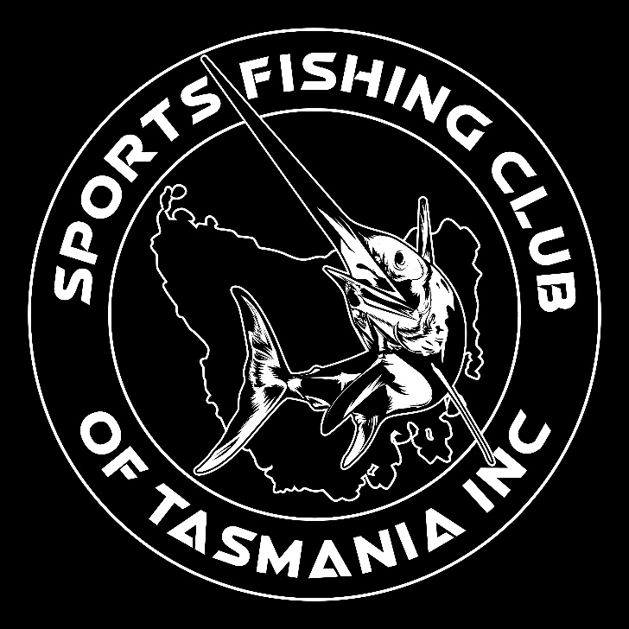

2024 Derwent Flathead Classic
Saturday 3rd February 2024, Geilston Bay Yacht Club
Official Entry Form 2024
Boat Name:
Captain Name & Mobile:
Full name | Address | Email | D.O.B.
1
2
3
4
5
Team cost $150 min 2 anglers max 5 per team.
EFT SFCOT BSB 067-100 ACC 10303415 REF Boat Name
Completed entry forms to be emailed to nickparkinson@bigpond.com Enquiries: 0406254859
- Single day membership to SFCOT included in entry
- Can be upgraded to full SFCOT/TGFA/GFAA membership for $50 per adult, $35 junior/small fry at any time.
DISCLAIMER**
All entrants required to fill out membership form, and each skipper MUST fill out the Vessel Detail Form with current insurance policy, available on club web page. I/we confirm that I/we confirm that I/we are aware of the Sports Fishing Club of Tasmania Inc competition contests and rally rules and regulations and we will abide by MAST inshore and offshore marine vessel safety requirements. I/we acknowledge and accept the risks (Including the risk of harm to persons and property and the risks associated with the perils of the sea and the seaworthiness of any boat) associated with participation in any SFCoT competition, Contest or rally waives all rights against and releases the SFCoT and their committee, members and representatives, in respect to any loss of life or injury to persons, or loss of damage to property, suffered in connection there with: I/we acknowledge that participation in any of the SFCoT Competitions, contests and rallies by the boat and by each member that signs this form agrees to sign on the basis as a disclaimer and acknowledge that participation is entirely at the risk and responsibility of the boats skipper and crew and that the Sports Fishing Club of Tasmania Inc are totally not responsible for the boat or any of their crew.
Signature Angler 1 | Signature Angler 2 | Signature Angler 3 | Signature Angler 4 | Signature Angler 5

